Software Requirements Specification

for
UNO Card Game
Version 1.0 approved

Prepared by Alekhya Vanga

Western Illinois University

October 09, 2017
Table of Contents
Table of Contents ii
Revision History iii
1. Introduction 1
1.1 Purpose 1
1.2 Document Conventions 1
1.3 Intended Audience and Reading Suggestions 1
1.4 Project Scope 2
1.5 References 2
2. Overall Description 2
2.1 Product Perspective 2
2.2 Product Features 2
2.3 User Classes and Characteristics 3
2.4 Operating Environment 3
2.5 Design and Implementation Constraints 4
2.6 User Documentation 4
2.7 Assumptions and Dependencies 4
3. System Features 4
3.1 Start Game 4
3.2 Choose Color 4
3.3 Drop Card………………………………………………………………………………………….5
3.4 Draw Card…...…………………………………………………………………………………….5
3.5 Call UNO…………………………………………………………………………………………..6
3.6 Exit Game………………………………………………………………………………………….6
3.7 Try Again…………………………………………………………………………………………..7
4. External Interface Requirements 7
4.1 User Interfaces 7
4.2 Hardware Interfaces 7
4.3 Software Interfaces 8
4.4 Communications Interfaces 8
5. Other Nonfunctional Requirements 8
5.1 Performance Requirements 8
5.2 Safety Requirements 8
5.3 Security Requirements 8
5.4 Software Quality Attributes 8
6. Other Requirements 8
Appendix A: Glossary 9
Appendix B: Analysis Models 9
Appendix C: Issues List 10

Revision History
Name | Date | Reason For Changes | Version
Alekhya Vanga | October 09,2017 | N/A | 1.0

Introduction:

Purpose:
This document gives a exact requirement specification about how to play the UNO game. The game is featured in a software version to play. Basically the document consists of rules and regulations to play the UNO game. This document consists of all the information needed and pre-requisites that will guide you through for implementing, testing and playing the game.

Document Conventions:
This document ranges till 13 pages including the cover page on letter size paper in portrait orientation. Each section contains paragraph numbering and naming. Each major section begins on a new page. Page numbers are on right of the header. Headings are in Times New Roman font 18pt for section headings and 14pt for subheadings. Body text is in 12pt Times font.

Intended Audience and Reading Suggestions:
This document is for the students taking the CS 585 Topics in Software Engineering course and also for the instructor who will evaluate and give the necessary information about the game. The primary objective of this document is to tell all the users about the functions about the Blackjack game, on how the game is implemented and would take the necessary advice of comments or suggestions. This document is organized as follows:

- Introduction
- Overall Description
- System features
- External Interface Requirements
- Other Nonfunctional Requirements
- Other Requirements

Appendix A Glossary
Appendix B Analysis model
Appendix C Issues list

Project Scope:
The major feature of this product which makes a big scope is that it deviates from the standard hand mode and is now played on a machine. The game has been made up in a software by a java program, which allows users to play UNO game on a computer. The program has the option of implementing a new game.

References:
https://www.unorules.com.

https://en.wikipedia.org/wiki/Uno_(card_game)

Overall Description:

Product Perspective:
We consider the cards of deck as an implementation of the UNO card game.

Product Features:
This product is based on the card of decks, which has a minimum of two players (Which can go up to a limit of 4 for a standard game) , the deck and one user player. We have the following features of this product.

Start Game:
This is the inception for the game where the function starts a new UNO card game.

Choose Color
The user who needs to start the game has a right to choose the color.

Draw Card:
In order for the game to start user needs to pick a card if he did not have the card color of which the game started. If not the starting user needs to pick a card till he gets the color to be dropped.

Drop Card:
The user needs to drop the card color which is currently in progress.

Draw two:
This card is a different one which a user should mandatorily take two cards irrespective of himself having the card of the running color.

Call UNO:
When a user is down to one card he needs to call “UNO”. Otherwise he will be penalized.

Exit:
This function says if the user is having no cards he is declared the winner and prompt to exit.

Try Again:
If the user wishes to start a new game.

User Classes and Characteristics:
The game is designed for users of all ages. The game is been made in a global understanding English language. Considering the users, a novice user will be taking less considerations for a hit but a professional user will be making a big move.

Operating Environment:
The software is designed to run on many platform which has Java Virtual Machine 1.6 or the next ones. Supported operating systems include Microsoft Windows and Mac OSX and also will be running on java used machines.

Design and Implementation Constraints:
This software has been developed in Java on Net beans IDE for a faster and easy complexity use.

User Documentation:
A user manual is given as a guide through for the UNO game.

Assumptions and Dependencies:
Not applicable for this application.

System Features:

Start Game
- Description and Priority:
This feature allows the user to start a new game to play UNO.
Priority: High – must be implemented in the first version.
2. Stimulus/Response Sequences:
- The User selects this feature from the application interface from the menu bar.
- If selected, user will be taken to a new screen where the user can start the game.
3. Functional Requirements:
REQ :- 1: The User must select this feature by interfaces like keyboard or mouse.

Choose Color:
1. Description and Priority:
This feature is for the user who starts first and has a right to select the card color in order to start the game.
Priority: High – Must be implemented by first version

2. Stimulus/Response Sequences:
- Initially in beginning, the starting player will be given a right to choose the color.
- Now once the player chooses the color it is going to be accepted and other players drop cards of the same color unless someone has a card which the color can be changed.

3. Functional Requirements
REQ-1: The user choses the color using the mouse.
3.3 Drop Card:
- Description and Priority
This feature allows a player to drop a card which is being started by its color.
Priority: – must be implemented in the final version.
2. Stimulus/Response Sequences:
1) User drops a card of a color which has been specified in the first user’s turn.
2) He can even drop a card which changes the color of the card.
3. Functional Requirements
REQ-1: The User must select a card in his available set in order to drop it.
REQ-2: The card can be selected by the mouse.

3.4 Draw Card:
1. Description and Priority
In this scenario it lets the user decide to draw a card.
Priority: High – must be implemented in the first version.
- Stimulus/Response Sequences
1. Player user notifies that it is now his turn.
2. This feature will remain active as long as it is still the player user’s turn. And until the user drops his card.
3. Once this feature is used, the current player turn will end, and it goes the next player’s turn.
- Functional Requirements
REQ-1: This feature will be available any time during the player’s turn.
REQ-2: Using this feature shows that the player is interested in drawing more cards and drop the specific color card and to pass the turn to the upcoming next player.
REQ-3: Once this feature is used the player cannot play until his next turn is given.

3.5 Call UNO:
- Description and Priority
In this scenario the feature allows the player to call UNO if he is left with one card.
Priority: High – must be implemented in the first version.
- Stimulus/Response Sequences:
1. Player notifies that it is his turn.
2. Then he calls UNO.
- Functional Requirements
REQ-1: Now the user must select this feature let other players know .
REQ-2: A button should become active only if a player has 1 card left
REQ-3: The User must select this feature by interfaces like mouse.

3.6 Exit Game:
1. Description and Priority:
This feature allows the user to end the game and return to main menu so that the user can restart or exit.
Priority: High – must be implemented in first version
2. Stimulus/Response Sequences
Now the Game ends and the user is returned to main menu
3. Functional Requirements
REQ-1: User must enter keystroke to end current game.
REQ-2: The game has ended and the main menu is displayed on the screen.

3.7 Try again:
- Description and Priority
In this scenario the feature allows the players to restart the game.
Priority: High – must be implemented in the first version.
- Stimulus/Response Sequences:
The user will be taken to a new window so that he can restart the game.
- Functional Requirements:
REQ:- 1: The User must select this feature by interfaces like mouse.

External Interface Requirements:

User Interfaces:
4.1.1 User Interface Description

The game can be run on any computer/platform that has Java Virtual Machine installed on it. The UNO interface is a GUI, which runs in multiple windows with buttons and bars to navigate through them. UNO is a card game which involves multiple players and a deck.

4.1.2 Start Game

At inception point in starting the UNO game, all the players receive 7 cards each. After the cards are given, the game continues with the first player taking action by choosing a color of the card and dropping a color which he has chosen. Then the game continues in clockwise order. Then according to the rules if the user is left with no cards is the winner.

Hardware Interfaces:
There cannot be any hardware interfaces for this software. So this software is not applicable for hardware.

Software Interfaces:
The software will be self-sustaining and the system requires java for the software interfaces.

Communications Interfaces:
Not applicable for this game.

Other Nonfunctional Requirements

Performance Requirements:
We consider the Performance requirements once the game was played to evaluate.

Safety Requirements:
Not applicable for this game.

Security Requirements
Not applicable for this game.

Software Quality Attributes:
There are basically some attributes which are clarity, portability and usability. This product should provide the instructions and gameplay that allows a user to play UNO in a manner that is clear and accurately shows the current state of the game process. To ensure portability this software is to be written in Java in different platforms.

Other Requirements:
None.

Appendix A: Glossary:
All the required abbreviations and acronyms have been clearly defined in this project and any future updates with different scenarios will be updated accordingly.
Appendix B: Analysis Models:
Use case diagram for UNO game:
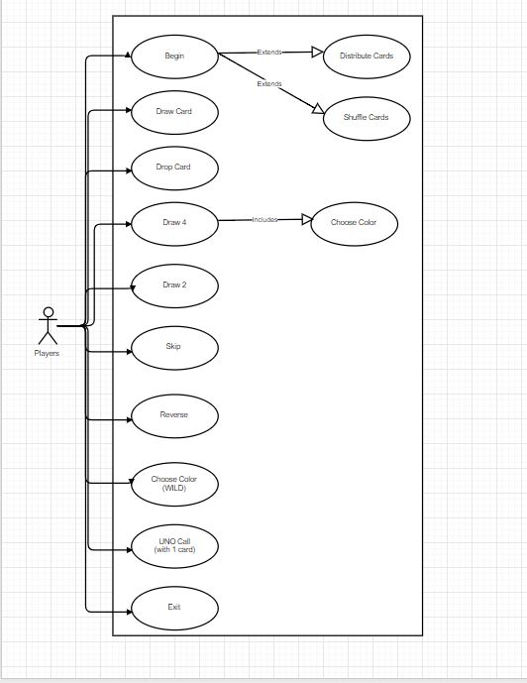

Appendix C: Issues List:
As of now this product has been done without any bugs and if any will be rectified and restored by updating the product.

